Computer Language Coding Concepts

Parameters & Arguments in a Diagram
The article Parameters & Arguments conceptually explained the usage of the term argument in relation to parameters. The current article gives examples of the diagrammatic expression of parameters and their arguments.

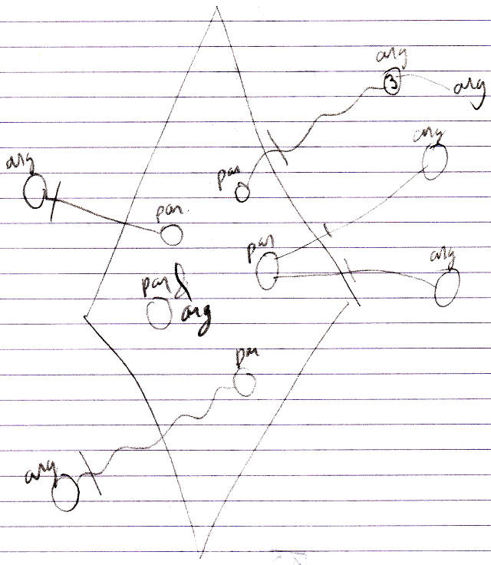

See also: Parameters & Arguments

Author & Copyright: Jan-Joost van Zon Date: May 24, 2008 – September 30, 2008 Location: Oosterhout, The Netherlands Status: Finished

